**Git and GitHub in Ubuntu Server**



**Learning Outcomes**

* Understand the concept of version control system (VCS)
* Create GitHub account
* Create GitHub repository
* Use Git, GitHub
* Do 1 add, commit, and push git operation

**Assignment Submission:**

* *Capture screen shots of your practice session results and paste* ***into this document accordingly****.*
* *Your can choose a different Git Repository for practice in this exercise.*
* *Add/Replace the “demo” screen shots seen in this document with your results.*
* *Please elaborate as needed.*

Please submit online. If that fails, email your results to our course TA. The subject of the email should be: [Your StudentID, Assignment Name]

**Before you start**

Version control system (VCS) is created to makes it easy to store different versions of the project you are working at any time (without any fixed rules, time or rules). You can easily restore an earlier record and compare the content with the current data to find the differences. In addition, it also an effective tool to cooperate with many other people in the same project. In this module, we will learn about one of the most popular VCS which is Git and GitHub.

First of all, Git and GitHub are not the same thing. Git is a VCS while GitHub is a hosting server for software development version control. The way Git works is that it creates a **repository** to store each version of the project every time developers modify or add some features into the project. Developers use Git through terminal or command line.

However, Git only allows you to control your project version on your local machine. Therefore, if there are 2 or more people working on a same project, how do we connect the works of all the members? That is why we need a hosting server GitHub.

To learn more about Git and GitHub visit:

<https://codeburst.io/git-and-github-in-a-nutshell-b0a3cc06458f>

<https://git-scm.com/book/en/v1/Getting-Started-Git-Basics>

**Registering a GitHub account and GitHub repository (If you already have a GitHub account, skip to step 7)**

1. Visit <https://github.com/> and click on “Sign up for GitHub”

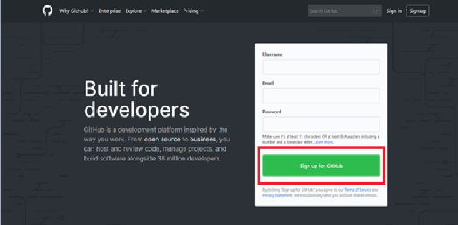

1. Filling in the form with Username, Email Address, Password and etc. It is very straightforward.

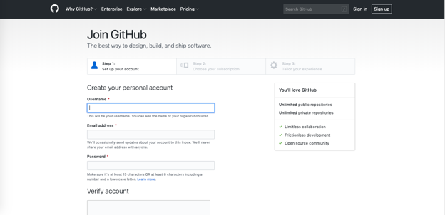

1. Click “Create Account” to proceed to next page
2. On Step 2, Choose your subscription as “Free” and click “Continue”
3. 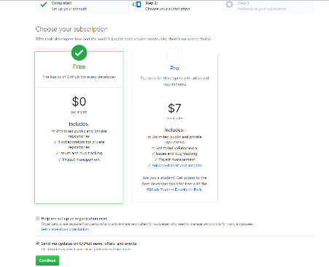
4. On Step 3, just be honest and choose your options then click “Submit” or you can just click on ‘skip this step’



1. After that, you will be asked to check your email and verify your GitHub account
2. Go to github.com and login to your GitHub account.
3. Please submit your username

**Joining as a collaborator in a GitHub repository**

You’ll be invited to be a collaborator in amazon-apprenti-2019 GitHub repository. Please check your email.

**Ubuntu Server**

**Preparation**

1. Connect to your Ubuntu instance

Open a command prompt

**Check Git**

Check your if your ubuntu server has git.

>>> git --version



**Cloning a repository**

1. Clone (copy) the remote (online) repository to your local machine

>>> cd ~

>>> git clone https://github.com/PengWang0316/amazon-apprenti-2019

e.g.



1. Go to the project folder

>>> cd amazon-apprenti-2019

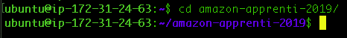

1. Go to folder CS120

>>> cd CS120



**Saving your credentials**

To avoid logging to your username and password every session, please execute the command.

>>> git config credential.helper store



**Branching out from master branch**

1. Create your own branch

>>> git checkout -b 'firstname-lastname'

Please replace your *firstname* with your real first name and *lastname* with your real last name.



Make sure you see console output “Switched to a new branch”

**Creating your own content**

1. Create a folder with your name inside CS120

>>> mkdir FirstnameLastname

Replace *FirstnameLastname* with your own first name and last name



1. Go to your FirstnameLastname folder

>>> cd FirstnameLastname



1. Create a folder with the current Module number inside your folder with FirstnameLastname

>>> mkdir Module2



1. Go to Module 2 folder

>>> cd Module 2



**Push your first file**

1. Create a README.md file with the touch command

>>> touch README.md

Use ls command to double check



1. Add the file to staging

>>> git add README.md



1. Commit the file and add a message

>>> git commit -m 'your commit message'



1. Push your branch to GitHub repository (Note: this step may not succeed due to Repo owner permission)

>>> git push origin YOURBRANCHNAME

Change the YOURBRANCHNAME to your own branch name (firstname-lastname)

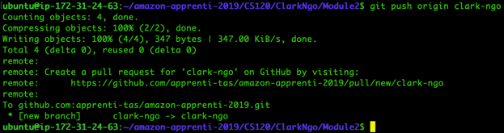

5.When prompted for GitHub username and password. Enter them

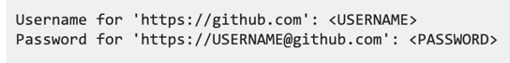



**In case step 4, and 5 fails, as the Repo owner does not accept you as a collaborator, then create your own repository as shown below.**

**Log into your GitHub account, then create a new repository.**

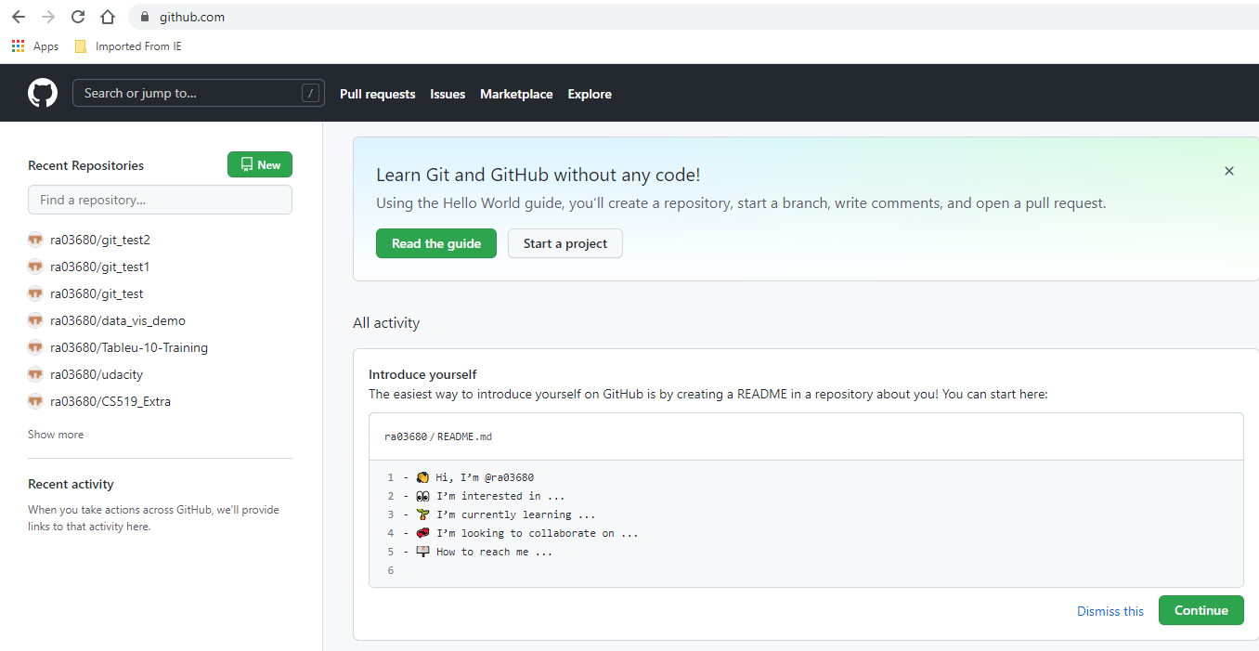

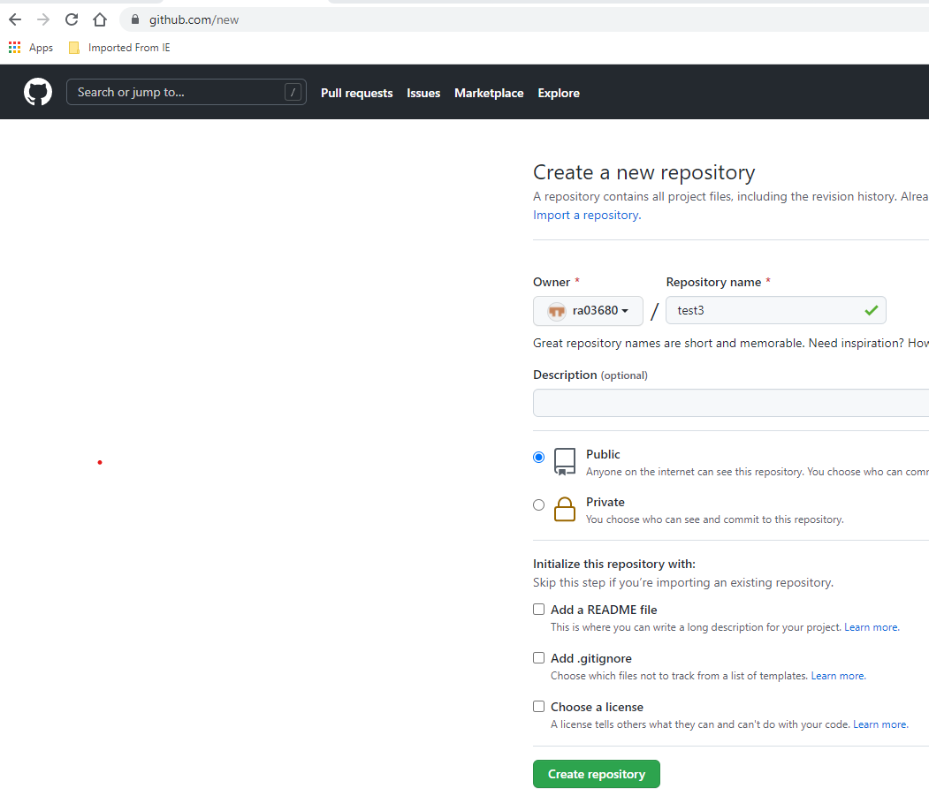

**Creating a new file, or uploading an existing file:**

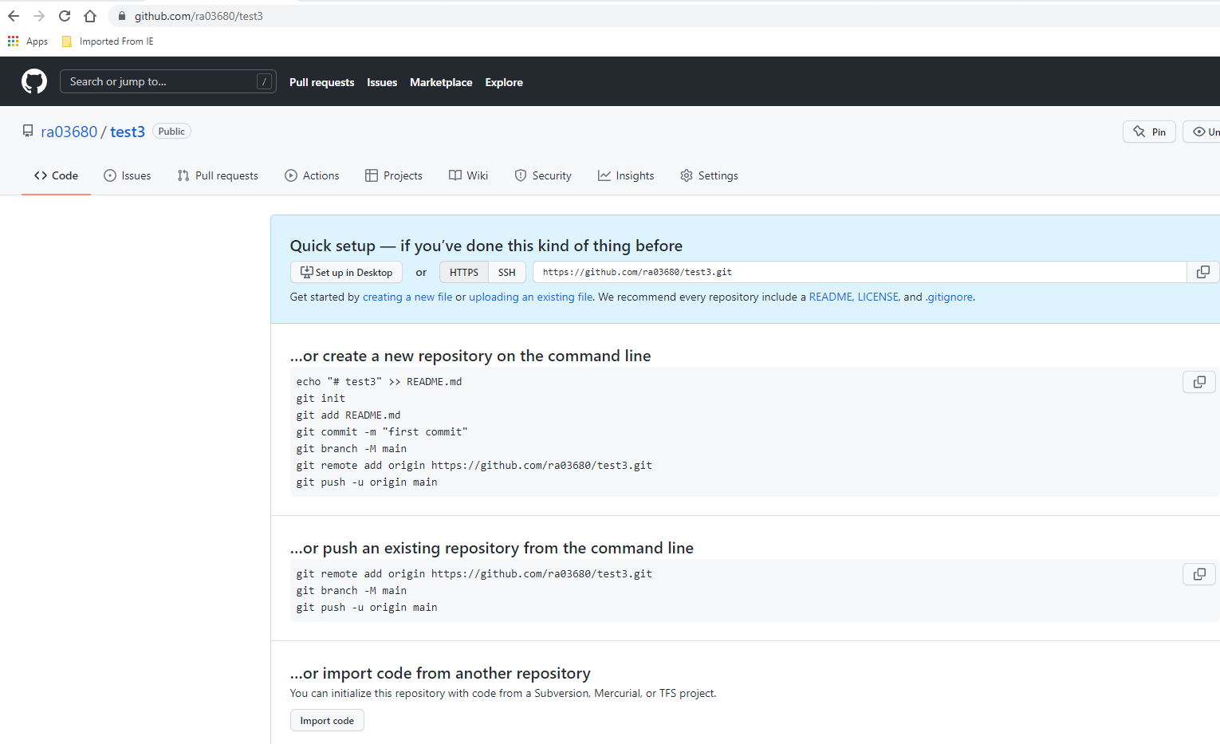

**Add your files/folders:**

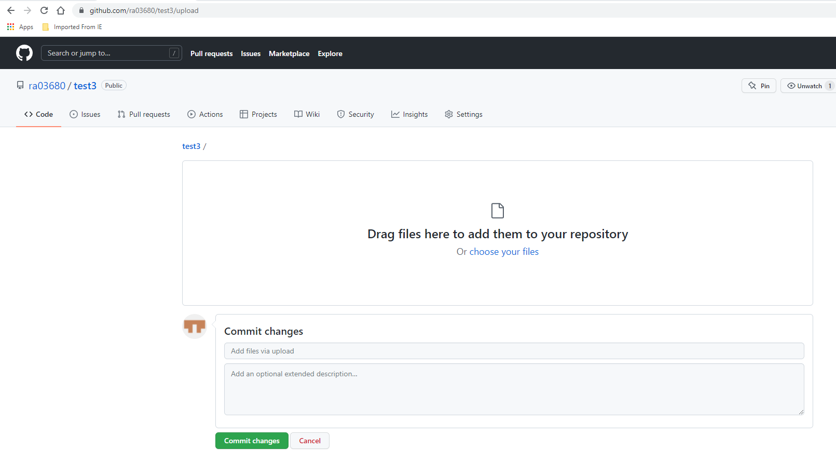

**Windows OS**

**Creating a pull request**

1. Switch out of Ubuntu Server terminal and open a browser in Windows OS.

2. Go to <https://github.com/cityuseattle/amazon-apprenti-2019>

If prompted for username and password, please enter them.

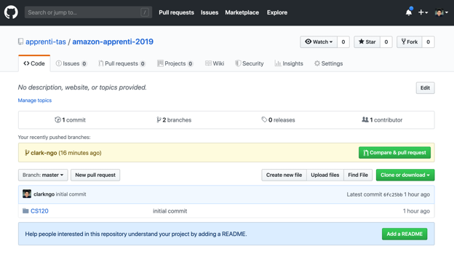

3. Click branches



4. Click Yours



5. Click Create pull request



6. You have successfully created a pull request. Now, the maintainers of the repository would accept or reject the pull request.

Accepted pull request means you have followed the correct file structure and there were no conflicts in files.

Rejected pull request means, you need to redo the steps and make sure it follows our guidelines.

